16 March 2023

Barber Grove to Seaview Wastewater Treatment Plant Duplication Project

Community Update

Welcome to our latest project update! On behalf of Hutt City Council, we’re duplicating a section of old wastewater pipe (its 60 years old) from the Barber Grove Pumpstation down Randwick Road and Seaview Road finishing at the Seaview Wastewater Treatment Plant.

Since our last update in December 2023, we have:
- Relocated the large green tunnelling plant from Randwick Road to the Seaview roundabout
- Completed preparation work and launched Te Rū Tiokaoka down into the Seaview roundabout - the micro tunnel boring machine (mTBM), for the third and final 230 metre drive towards Pirie Crescent
- Relocated a watermain on Seaview Road to provide space for the new wastewater pipe
- Continued installing the new polyethylene (PE) pipe into the tunnel on Randwick Road
- Installed 24 metres of new pipe under the Waiwhetū Stream
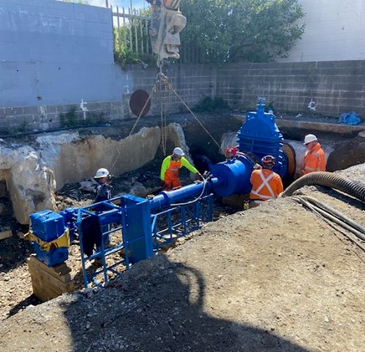
- Successfully completed new connections and upgrades to the Seaview Wastewater Treatment Plant and Barber Grove Pumpstation – read more about ‘hot-tapping’ below
- Installed new drainage and finished pipe ramming the first section of pipe down Barber Grove
- Commenced the excavation on the second half of the Barber Grove trench as we prepare to install pipe towards the Randwick Road retrieval shaft

What are the benefits of the project?
This project is a critical addition towards strengthening council infrastructure and protecting our waterways. With pipes nearing the end of their useful lives, coupled with the growth experienced across the Hutt Valley, this key infrastructure is under pressure and it’s crucial we invest before a significant event such as an earthquake. This project builds resilience into the wastewater network, reduces the risk of overflows, protecting the environment in the event of a major earthquake.
Figure 1: Hot Tapping underway at the Seaview WWTP
Traffic management
The crew are back in Seaview Road to complete the connection of a wastewater pipe we laid last summer. As a result, a one-way system was recently installed, with a northbound detour via Barnes Street. This will be in place for up to four weeks. Please be ready for delays, particularly during the morning and afternoon peak. We’ve had questions about the traffic management in place on Seaview Road and have compiled some FAQs on the project webpage to answer these: https://www.wellingtonwater.co.nz/projects/the-barber-grove-to-seaview-wastewater-treatment-plant-pipe-duplication-project/?tab=4&update=145 .
At Barber Grove, temporary traffic lights are operating to manage traffic flows.
Our existing traffic management on Randwick Road will remain in place until all works are completed, mid-2023. Please look out for our crew and follow their instructions. Cyclist and pedestrians are advised to follow all on-site directional signage showing alternative routes and/or shared-path facilities.
Thanks for your continued patience as we move towards the completion of this critical project.
What’s happening within the Seaview Roundabout?
It’s a hive of activity within the roundabout – the past two months have been busy!
We relocated the large green tunnelling plant from the Elizabeth Street site – this plant runs Te Rū Tiokaoka, the tunnel boring machine, mTBM. The shaft in the roundabout is 9 metres deep and approximately 6 metres wide. A 55-tonnes crane will remain within the roundabout during this work, along with diggers, truck and trailer units and utility vehicles.
How do we direct the existing wastewater to the new pipe? It’s called ‘hot tapping’
Hot tapping is a technique used to connect a new pipe to a live pipeline without switching off the flow. This is especially beneficial for making connections on infrastructure projects if taking a system offline is not an option. Until the current wastewater pipeline between Barber Grove and Seaview is duplicated, there is no ability to divert the flows, and so it must remain live while new connections are made.
What’s coming up over the next two months?
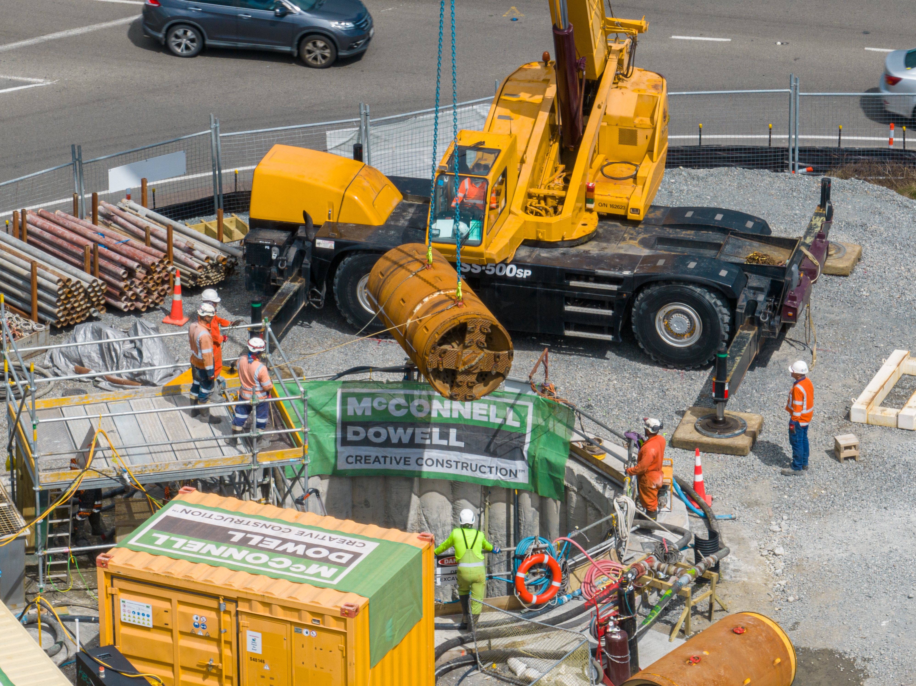
At Barber Grove, we continue to work within the grounds of the pumpstation to tie into the existing sewer network. We will continue to work in the roadway to lay new pipeline and connect it with the duplication pipe on Randwick Road.
Tunnelling continues under Randwick Road with the installation of the new PE pipe within the completed parts of the tunnel. On Seaview Road we will be trenching across the road to connect to the pipe we installed last year.
Once all sections of new pipe are installed, quality testing will be carried out to ensure our works are installed correctly and watertight.
Completion timeframes
We expect to complete all works, including final landscaping and reinstatement of the Lightwing Sculpture within the Seaview roundabout by mid-2023. Tunnelling involves a lot of variables which the project team has navigated well, unfortunately there are onsite construction conditions out of our control.
Figure 2: Te Rū Tiokaoka launched into the Seaview Road roundabout for the third and final tunnel drive

Our updated project timeframes and traffic management information is available on the project webpage - https://www.wellingtonwater.co.nz/projects/the-barber-grove-to-seaview-wastewater-treatment-plant-pipe-duplication-project/.
We will provide a further update on the project in May 2023. If you have any questions on the project in the meantime, please get in contact.

Nga mahi nui,

Liz Emery
Stakeholder Liaison Manager – McConnell Dowell
info@wellingtonwater.co.nz
0508 623 266

